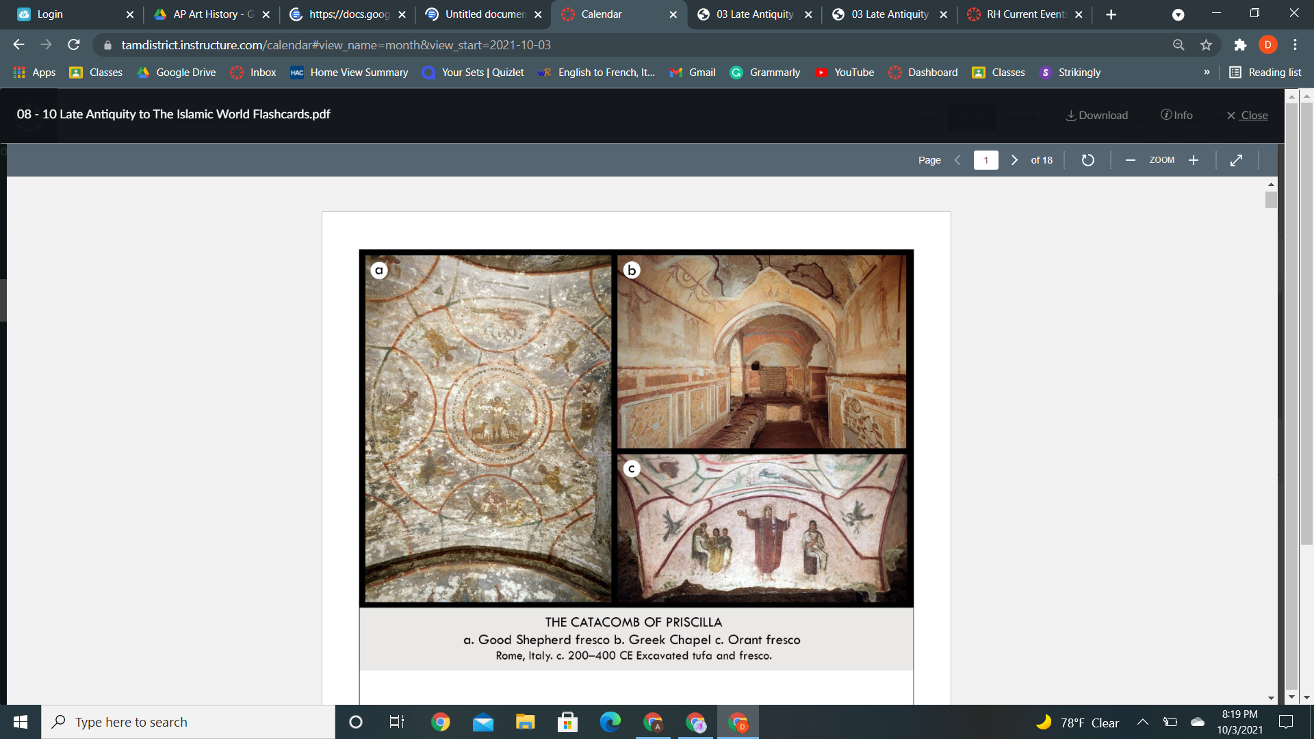

| **Form:**  Liunett style painting, orant gesture, seeing the way of combining the old and new testament. Fresco painting. 40 thousand tombs. Stacked one atop another, shelf-like slots covered over with stone.  **Function:**  As a place of Christian burial - tomb  **Content:**  Contains the tombs of 7 popes about 4 million dead buried in the catacombs in general (not specific). Wealthy Christian families had their own special spot cubicula, and paintings. Paintings in Pompeiian styles. Greek chapel= Weasley family buried. Motifs in the ceiling showing mothers praying ( arms up) show women’s life as teachers of children, and also show 3rd style Pompeii painting. Jesus as the Good Shepherd.  **Context:**  Christan catacombs were carved out of city walls because it was illegal to practice Christianity in Rome. Roman aristocrat Vasilisa allowed them to build them 7 miles of catacombs. The very oldest Christian art ever made in the catacombs. Christians were being [persecuted and were not tolerated in Rome. Roman empire  **Compare:**  **48**  Early Europe & Colonial America |
| --- |

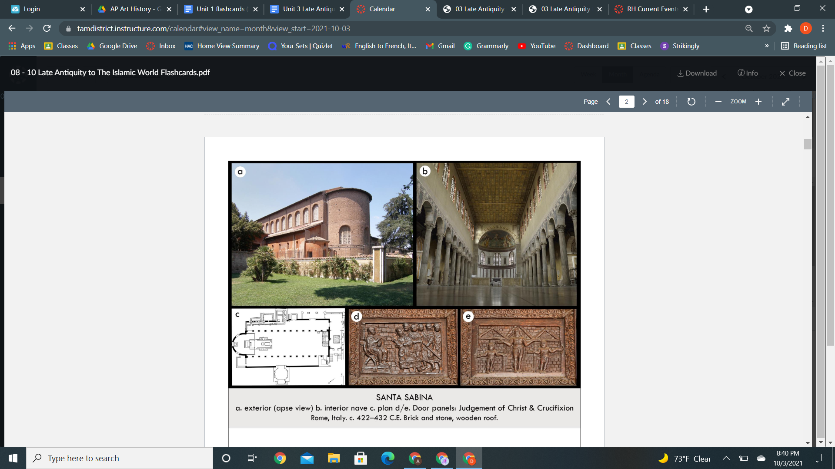

| **Form:**  Made of bricks on the outside, windows on the second story made of selenite rock. Does not have a transept. based on a Roman basilica interior held up by columns. Spolia with Corinthian columns around the sides of the nave. coffers on the roof made of wood. Massive, spacious longitudinal nave -Faces the altar -Illuminated by natural light from windows  Creates a feeling of transcendence, Light from the windows was manipulated by the architect to create a spiritual effect  **Function:** A church in Rome used for Christain worship (meeting house for Christian faith)- an early Christian church  **Content:**  Basilica has a long apse at the end. Windows made of *selenite,* not glass, Wooden coffered ceiling. Recalls the (domed) coffered ceiling of the Pantheon in Rome, circa 125 CE. Original paneled, wooden doors are still on the church. Depict Biblical scenes, possibly the first Crucifixion depiction in the upper left panel, Colonnade with a side aisle on each side- Corinthian columns. Like the Pantheon: walls are broken up into entablatures  **Context:**  One of the oldest Christian churches in the world was built in a 10 year period. Time of Constantine. Christianity was legal and churches were built. Late Antique Europe, 422-432 CE….On-site of Saint Sabina (300s in Rome,) who was stoned to death for converting to Christianity- the building was originally a classical Roman administrative building - Example of an ancient Constantinian basilica- Constantinian architects were the first Roman Christians; they chose the ancient Roman basilica to serve as the basis of their new churches.  **Compare:**  **49**  Early Europe & Colonial America |
| --- |

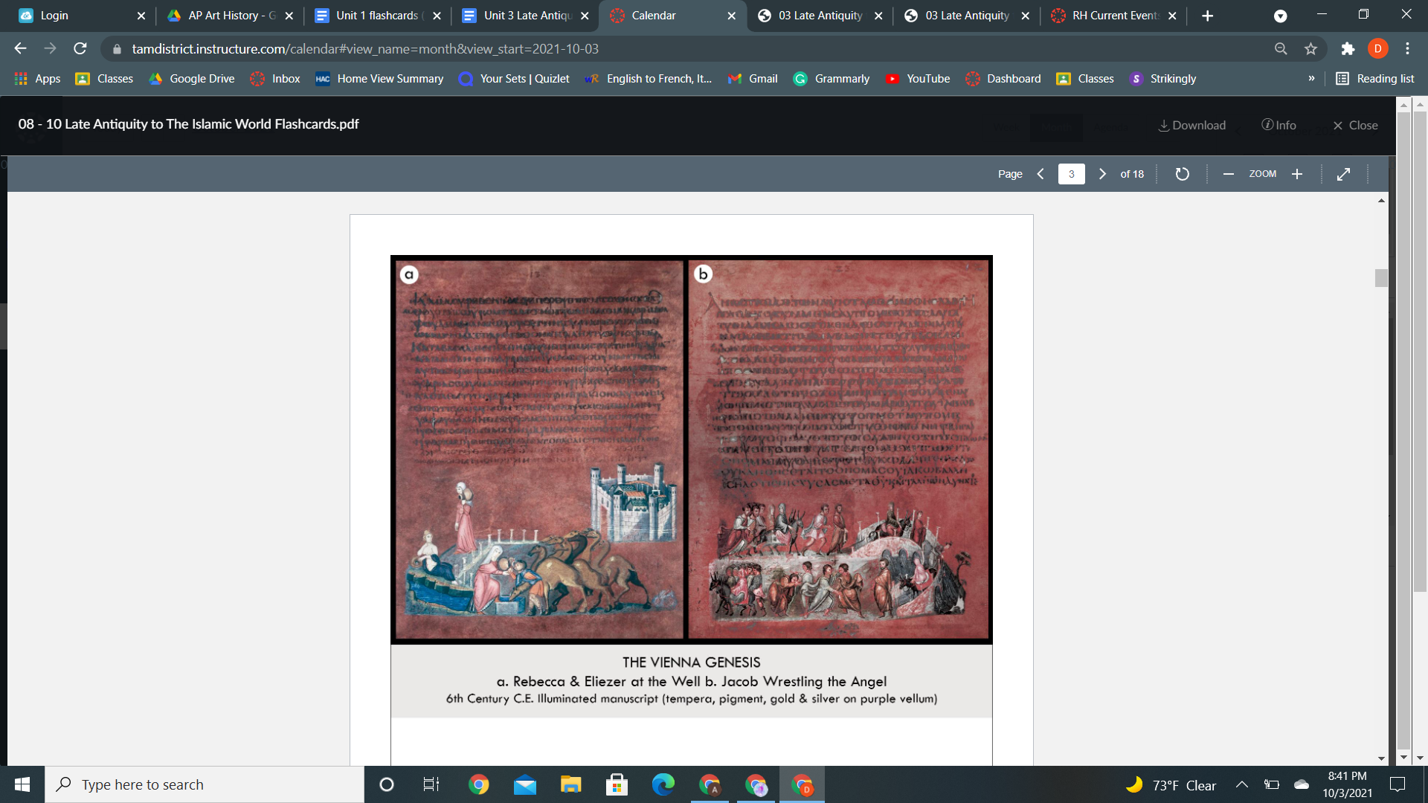

| **Form:** Pages made out of parchment dyed purple= color of power( very difficult to get from sea snail) painted in gold leaf and pigments, the script is silver stuck to the page. Byzantine, Continuous narrative, Animal skin pages  **Function:** A bible/ doctrine of Christian belief, used by royalty  **Content:**  Probably made in Constantinople/ royal workshop/ depicts the story of genesis, the first book of the old testament. Story of Rebeca and Eliza in the well, David is looking for a wife = sends adviser to find a wife at the well. ( drawn in a perspective but to the body is being drawn in a more classical style, combination of older and new styles of art. Shows the roman water goddess personifying spring. Rebeca uses it well to feed the camel driver= married David. Jacob Wrestling the Angles Story: Jacob leads his family across a river over a bridge. Then, Jacob has to fight with an angel. Upon fighting with the angle Jacobs’s name becomes Israel. Caught between realistic and abstract, Shows the medieval artists and patrons value of symbolism and abstraction, written in greek  **Context:**  Early codex= book that has a spine and a cover. Oldest illustrated bible in the world/ one of the oldest, shared by Christians and jews. Early Byzantine (330-726 BCE), The capital is moved to Constantinople, Christianity becomes the official religion  **Compare:** The Last Judgement of Hu-Nefer  **50**  Early Europe & Colonial America |
| --- |

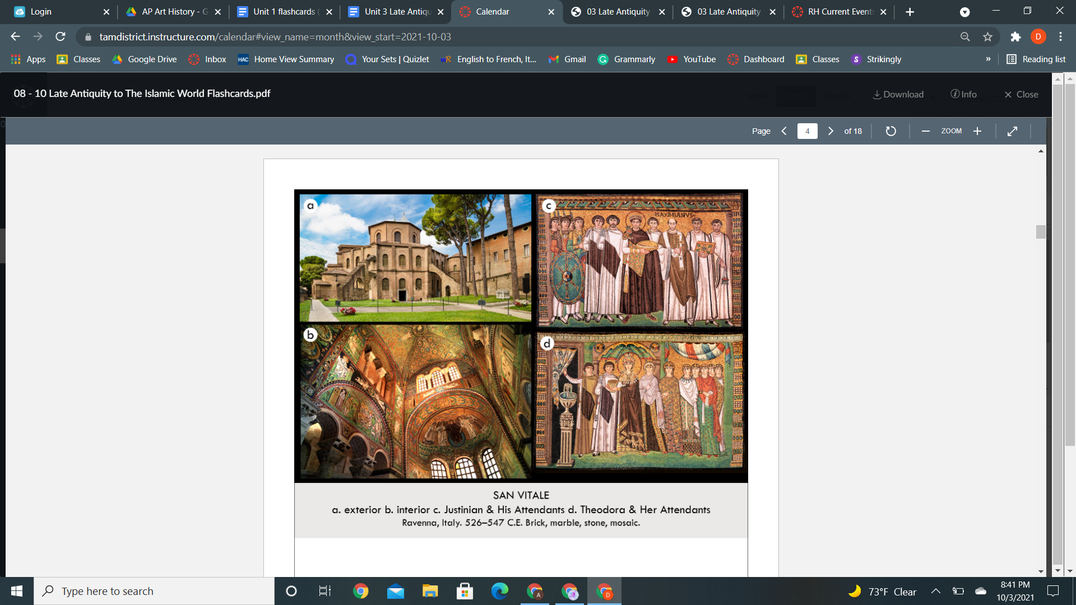

| **Form:** Centrally planned basilica, Octagonal in shape, Byzantine church, eastern orthodox style. Brick exterior was taken from Roman buildings. Interior covered in beautifully colored mosaics. Mosaics made out of glass, columns made from marble from the east. No old order Christians. Inpost blocks up to the arches Justinian and Theodora,  Mosaics use sharp objects to outline the picture of the mosaic, use a hammer and chisel-like blade= to produce tesserae pieces of the mosaic. Foundation has many layers  **Function:** political and religious propaganda, a Christian church  **Content:** filled with icons of christ/ Christianity. Covered with Byzantine-style art/ mosaic. Commissioned by Justinian. Centrally planned church, isle that surrounds the central place, apes at the end, have columns doubled, on mosaic is Christ dresses in purple holding a book of every surface is covered with artistry and art. She is the lamb of god who represents Christ’s sacrifice. Scene from the old and new testament. Justinian’s attempt of republishing revenue as western capital orthodox. Mosaic is showing the eucharist: not classically created, 2 dimensional. The Emperor is being depicted as divine; he is in the center of the composition, figure, and static and we have left the proportions and perfection behind. C. Emperor leading a procession the tesserae are set into the wall on angles. Theodora might rule as an equal and have power. Halo speaks to the divinity of position  **Context:**  Close involvement between you and what you’re seeing. 6th century planned church distance from the capital of the empire. Arians believe christ was not coequal with god-like the orthodox think, church meant the reincarnation of eastern orthodox control, the church the emperor, and the military.  **Compare:**  **51**  Early Europe & Colonial America |
| --- |

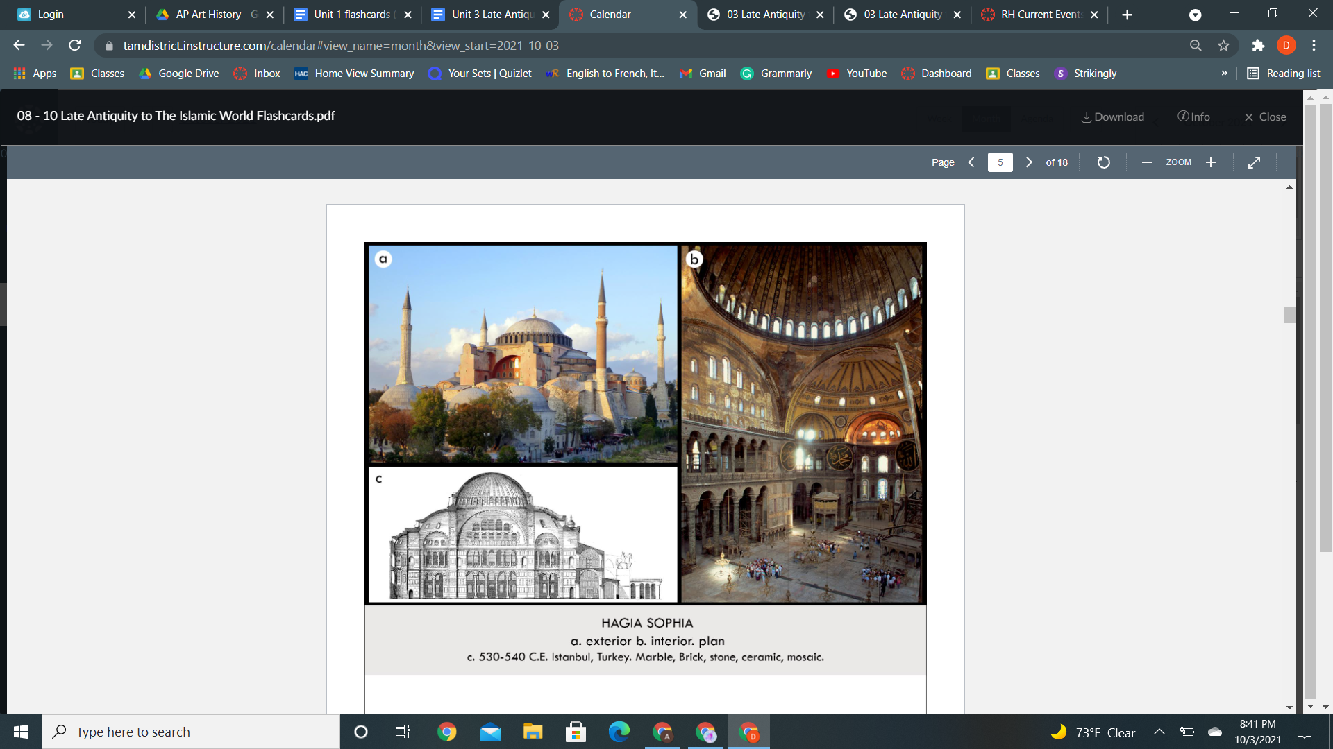

| **Form:** 270 ft long and 240 ft wide, 180 high, a supreme accomplishment of architecture. Interior covered in mosaics. Two floors centered on a giant nave with a great domed ceiling, along with smaller domes  **Function:** church of holy wisdom, Christians meeting house, today Islamic mosque  **Content:**  Dome appears floating on light, cut with arched windows, many windows, the triumph of architectural design in the middle ages. Characters from the Quran on the walls, combination of an Islamic mosque and a Christian church. Dome rests on pendentives that transfer weight to the square base( square becoming a circle). This allows a ring of windows at the base of the dome and creates. Combination of the domed basilica for the first time. and central plan church. Minarets added later. Parties were emperor Justinian and his wife.  **Context:**  First Christian church built by the Roman emperor in the eastern capital of Constantinople: the empire was crumbling in the west. overrun by the Ottomans. Designed by mathematician and physicist( Anthejmius of Tralles, Isidorus of Miletus. Built in the 6th century by emperor Justinian. Iconoclasm. Commissioned by Emperor Constantine  **Compare:** Parthenon, hindu temples, templo mejor,  **52**  Early Europe & Colonial America |
| --- |

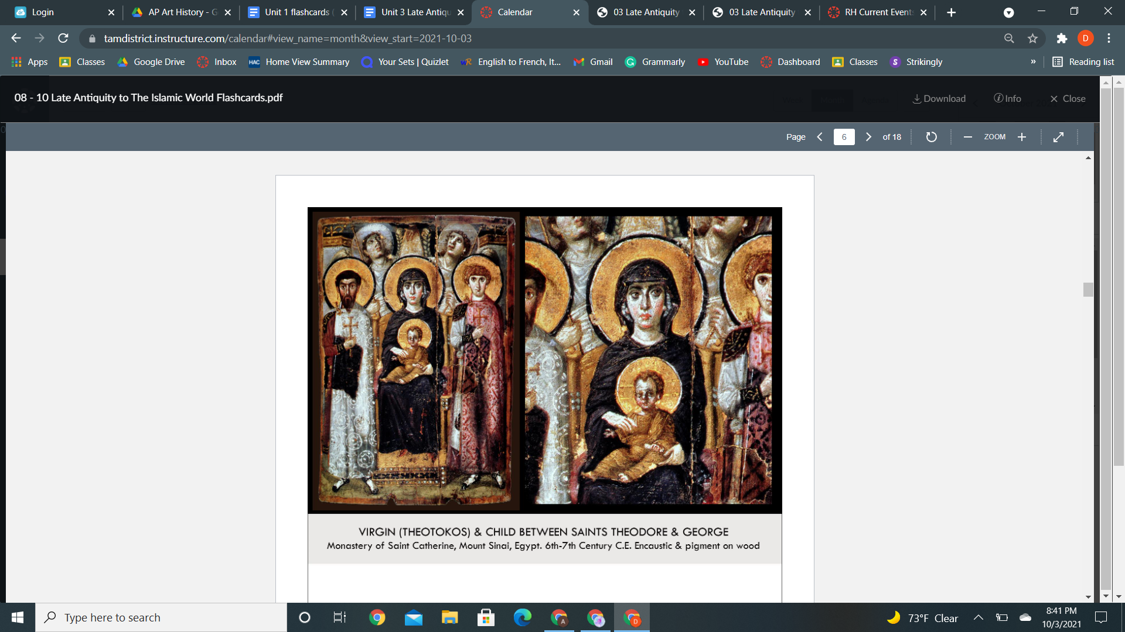

| **Form:**  Semiclassical style, all painted by different people, unsigned. An encaustic icon painting, Uses gold leaf  "icon" = image, painting (in Greek)  encaustic = a painting technique that uses wax as a medium to carry the color    **Function:**  A private devotional object (used to inspire the pious and help them express their veneration for God and enhance their spirituality)- icon  **Content:**  Classical Antiquity - the height of Byzantine Christianity  Modeling, Shadows, Naturalistic features (drapery), Movement, Created in the era in which Constantinople was restoring and creating dozens of churches ( time of artistic flourishment) As art become more of a part of daily life - pieces like *Virgin*  **Byzantine Traits:**  The compressed plane, Very flat (with little attempt to create depth), Simple body positions (limited realism), Emotionless faces, Front-facing figures (the saints), Huge, gold halos (to indicate divinity)  **Context:**  Subjects = the Virgin, the Christ child, Saint Theodore, Saint George, two angels, God  The Saints: St. Theodore = on the left & St. George = on the right, emotionless, their feet are lifted slightly off the ground ( divinity)  The Virgin: in the center of the icon, seated on a throne- elevated, highlighted by Heaven's light  The Christ child: in the Virgin's lap  The Angels: above and between the Virgin and the soldier saints, looking directly upwards, dressed in all white, highest in the frame and the furthest back (the most removed from our earthly realm)  God: represented by a hand emerging from the center of the top of the icon/ "Hierarchy of Bodies" Saints - Virgin+Christ - Angels -God  **Compare:** Terra-cotta Warriors, Parthenon, Koons, *Pink Panther* **54**  Early Europe & Colonial America |
| --- |

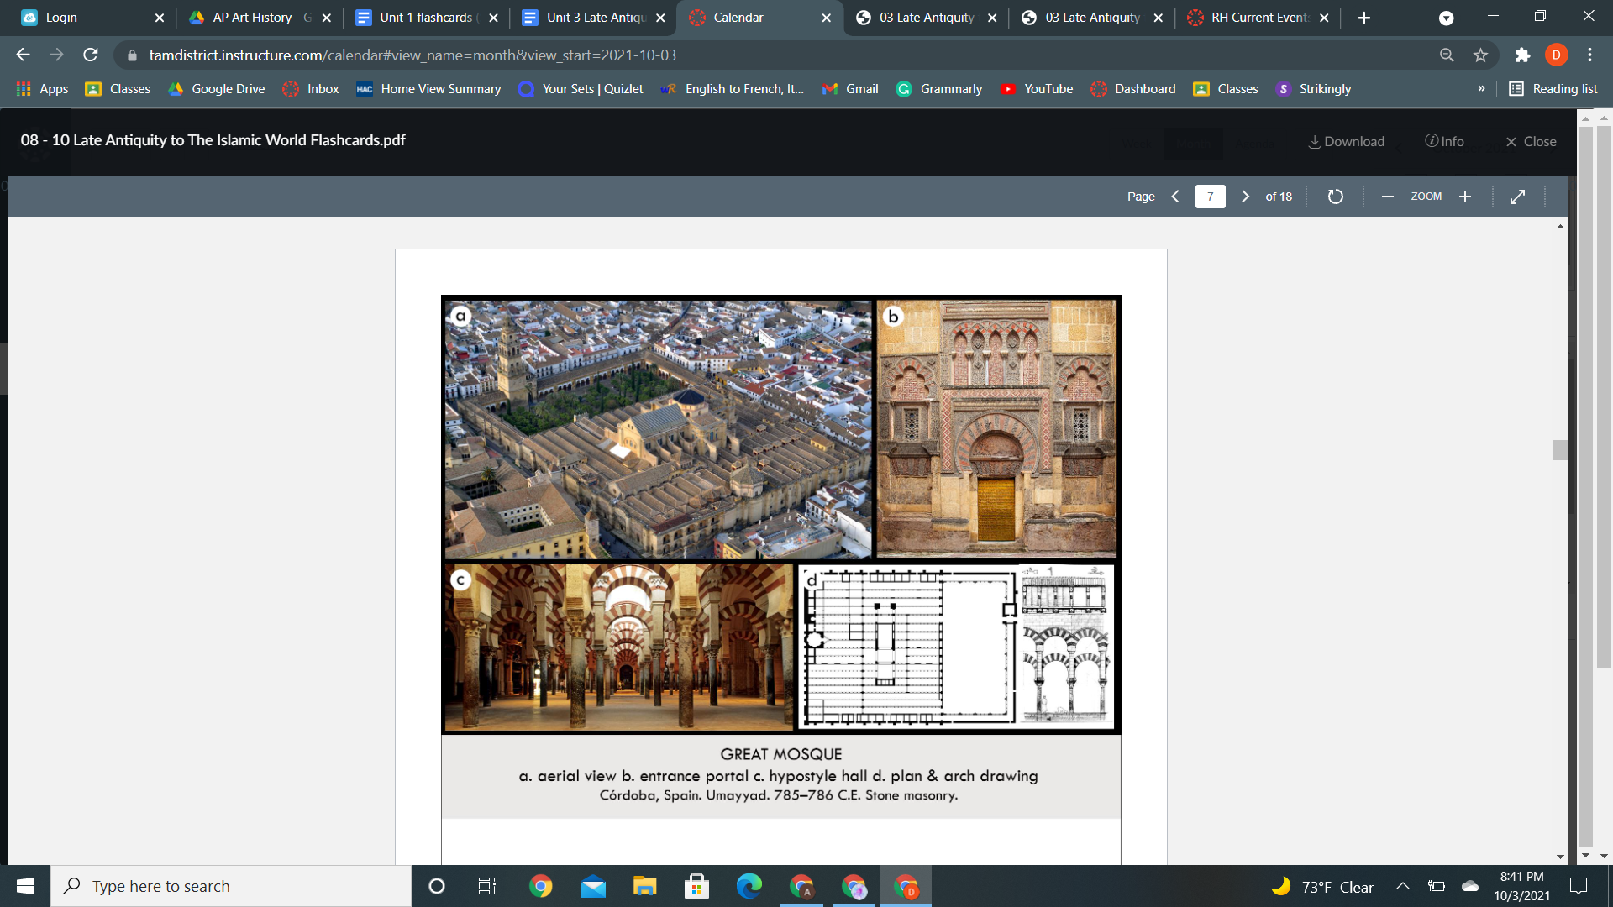

| **Form:** Based on a house plan. A church placed on top of it, a stone mosque built in Spain, has 36 peris and 514 columns, spolia used on columns with horseshoe arch on top of it, then doubles with, voussoirs striped on the top. 620x460 feet  **Function:** A prayer hall, a mosque of Islam, demonstrating the presence & permanence of the transplanted Umayyads in Cordoba/ fusion of cultures,  **Content:** Enlarged with an expanded prayer, all Masters, gates, and series of mosaic-covered domes in 961 by al-hakam 2. Hypostyle prayer hall. Uses a horseshoe-shaped arch ( created in north Africa). large hypostyle prayer hall, mihrab, Ribbed dome (Above the mihrab / central bay), a courtyard with a fountain in the middle, Mosaics, inscriptions from the Quran, and brilliant colors line the interior. Repeating elements (columns, arches, voussoirs) - establishes a steady rhythm within the structure  **Context:** Represents the Umayyad dynasty that began in 774, by Adb-al-rahman 1 caliph in 784. Demonstration of multi-cultural influence on their art, Ancient roman columns in hypostyle prayer hall were recycled from the original Christian church on site Interior uses *spoilia*  **Compare:** temple of Admin Ray, chart cathedral  **56**  Early Europe & Colonial America |
| --- |

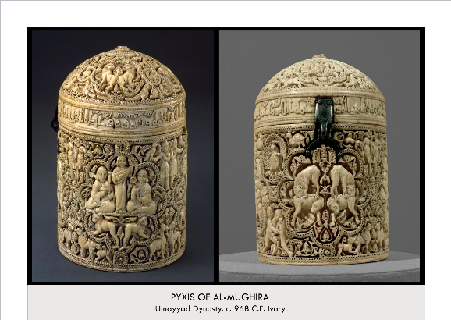

| **Form:**  Elephant Ivory - carved, covered with scenes of hunting and sport in royal court falcons, boars, musicians, in a horror vaculii ( fear of empty space) relief. Small jar with a metal clasp. 16cm tall and 11cm wide. highly desirable for the creation of pyxides (the plural of pyxis)  **Function:**  Luxury object, intended to hold incense ( says inside the jar). they were given as Caliphal gifts to important allies, such as the Berbers  **Content:**  There is image-making - which is unusual in Islamic art, unknown artists. decorated with four eight-lobed medallions-These medallions are surrounded by figures and animals, including falconers, wrestlers, griffons, peacocks, birds, goats and animals to be hunted  **Context:**  Ivory was a luxury product. An object from Islamic Spain created for alimigira an Islamic caliph - ( leader). A best surviving example of the tradition of carved ivory in Islamic Spain, Spain was home to some of the most impressive Islamic art and architecture  **Compare:**  **57**  Early Europe & Colonial America |
| --- |

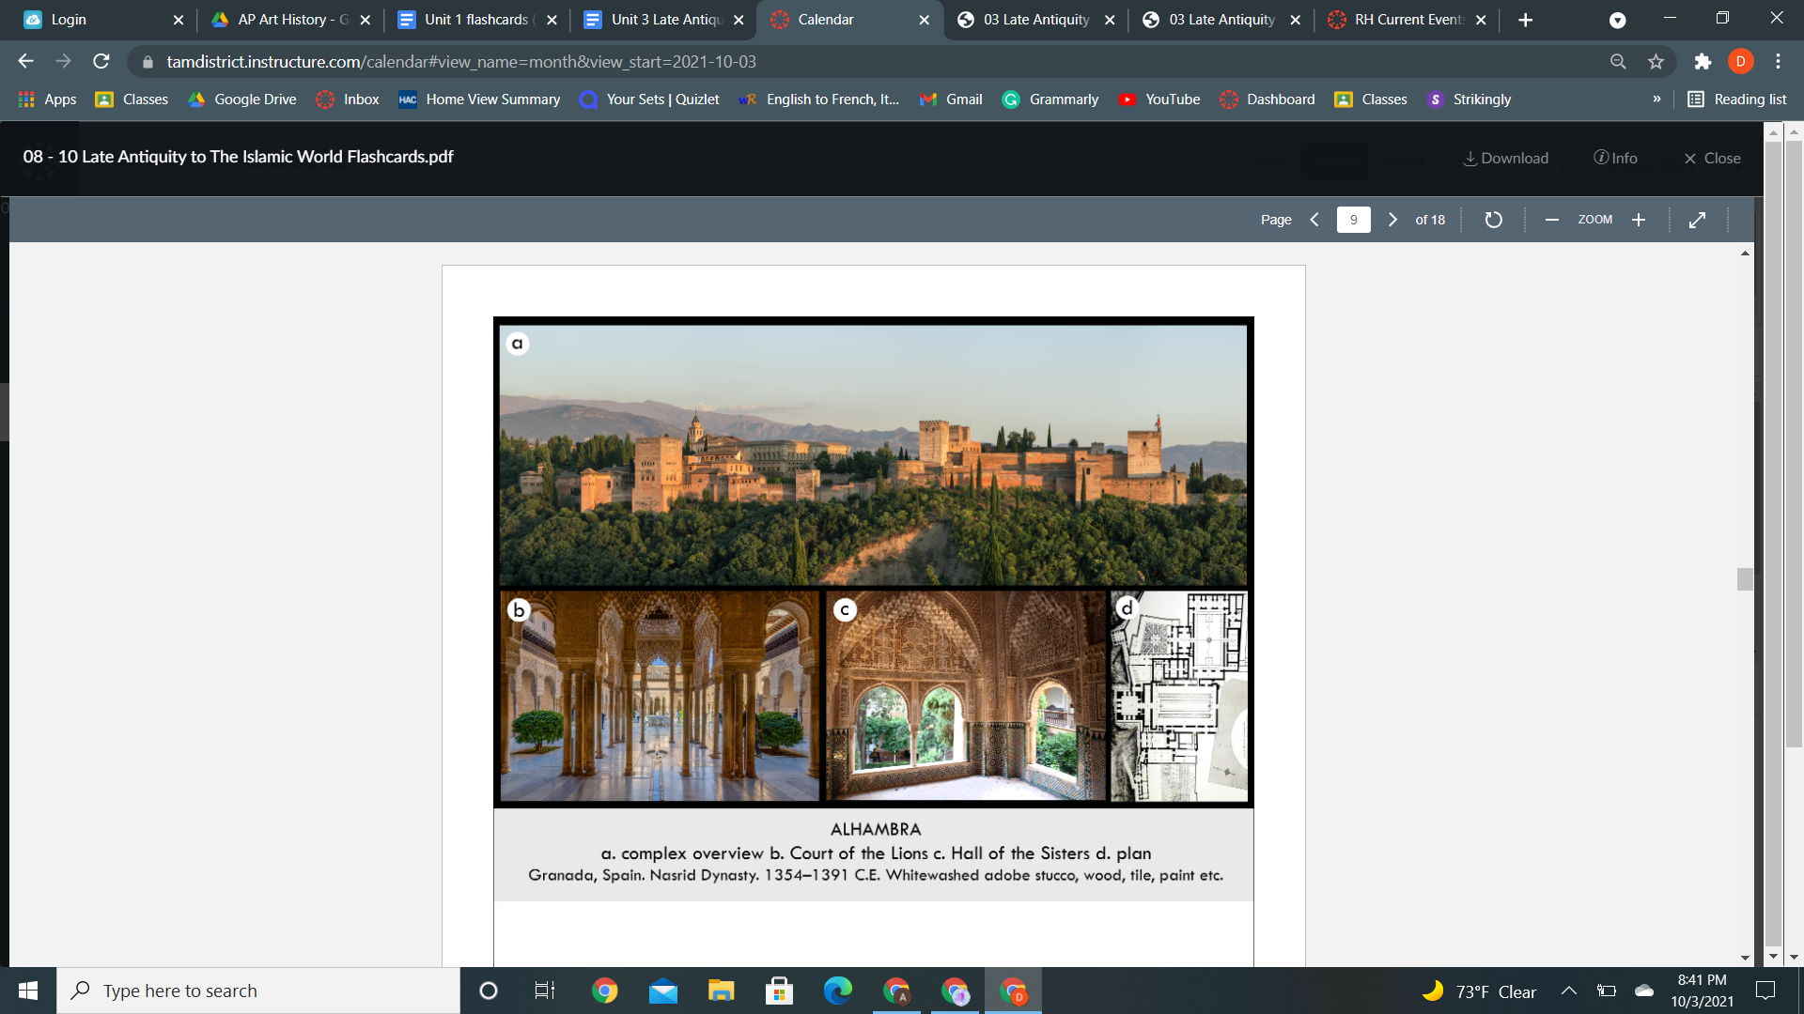

| **Form:** Whitewashed adobe stock with tile, painting, use of rhombus geometric forms, and calligraphy  Most of the interior arches are false arches, with no structure; they are there only to decorate.  Built on a hill overlooking the city of Granada  Walls are covered with beautiful and extremely rich ceramics and plasterwork.-Walls include intricately carved wooden frames, "muqarnas" hold up the ceiling in Hall of Kings--mocarabe vaults can be seen in Hall of the two sisters  **Function:** Hall: form listening to music/ reception room. Complex: Citadel, Barracks (Alcazaba, Residence ( palace of the Nasrid sultans)- Medina (the city)  **Content:** Fortace exterior and feminine interior, secular palace. Running water all through it. Columns, stucco decoration( mathematical patterns ) thin columns support the roof. Central pattern of lions, abstract pattern making. The ceiling has more than 5000 means carved into seccos  Contains palaces, gardens, water pools, fountains, and courtyards  Three Palaces- ( Comares Palace, the Palace of the Lions, the Partial Palace,) and Generalife- gardens  **Context:** Built by the Nasrid Dynasty (1232-1492) the last Muslims to rule in Spain.  Muhammad ibn Yusuf ibn Nasr (aka Muhammad I) founded the Nasrid Dynasty in 1237  Palace of the Lions built by Muhammed V, Exterior-Interior relationship, Important transition seamlessly form  **Compare:** palace of versed  **65**  Early Europe & Colonial America |
| --- |

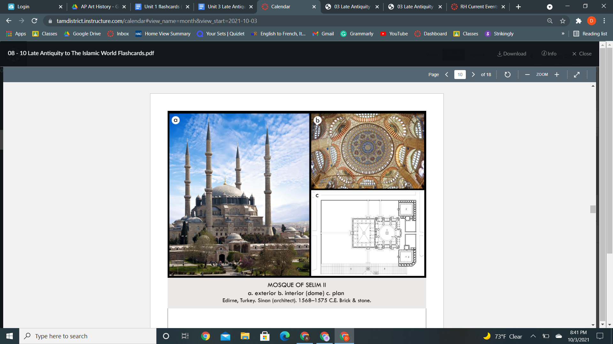

| **Form:**  The centralized dome on pendentives. Georouse minarets, granite columns from Egypt, stone. Blue pigments are used with lapis lazuli.  **Function:**  Testament to the greatness of the ottoman empire, and the power of the sultana and God- Allah. Religious art. Proclamation of Islams victory. Mosque, celebration  **Content:**  Shows aspects of light, hanging mosque lamps create light and a sense of openness. Stain glass windows. light= substance architectural element. muqarnas columns, not any other style. Indivisibility of space. Weightless space, 4 masonry piers. Airy light graphly- behind it is very mathematical. Part of Sulieman complex( library ex.) octagonal interior, octagon become a circle, interior has cuthic pattern making and script.  **Context:**  created by ottoman Turks, they are the ones that technically defeated the roman empire. Took aspects from st. Sophia and I used a basic plan. Mosque of Suleiman, of the ottoman empire. Ottoman empire was a large empire. Materials are taken from across the empire. (remaking of Hagia sophia=better). feels as if heavens are contained within the space. It is reconstructed and restored. Suleiman the Magnificent is the most powerful sultan of the Ottoman. Triumphant architecture for the triumph of Islam.  **Compare** Chartres cathedral in FrancekeepingThe wooden,are ofIslamPantheon, dome of the rock  **84**  Early Europe & Colonial America |
| --- |

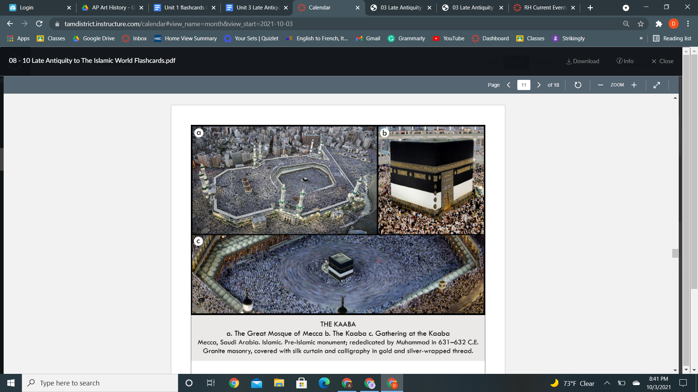

| **Form:**  Made of granite masonry blocks, covered in gold and silver bread, covered in gothic writing.  **Function:**  The spiritual center of Islam objects that they face when praying. Center of pilgrimage, the destination of the house, circle it counterclockwise 7 times(ritual) every Muslim must go here to prove faith.  **Content:**  In the holy city of Mecca, a religious city, the structure has been repaired and reconstructed several times. The only center building remains untouched. The site was once. made by Abraham and Ishmael his son (maybe) . The interior of the Kaaba is fitted with a marble and limestone floor. -This black brocade cloth that is hung around the Kabba is known as the Kiswah.  **Context:**  Faith if Islam there are 5 pillars once in your life you have to go to mecca.  Center is the kaaba= represents one god.  A very important place to them. thousands/millions of people gather. - Here God asked Abraham to sacrifice his son.  Muhamed came and leveled Mecca but kept this building is important because it is believed that Abraham and his son Ismail constructed it. It is symbolic of the journey and triumph of Muhammed.  **Compare:**  **183**  West & Central Asia |
| --- |

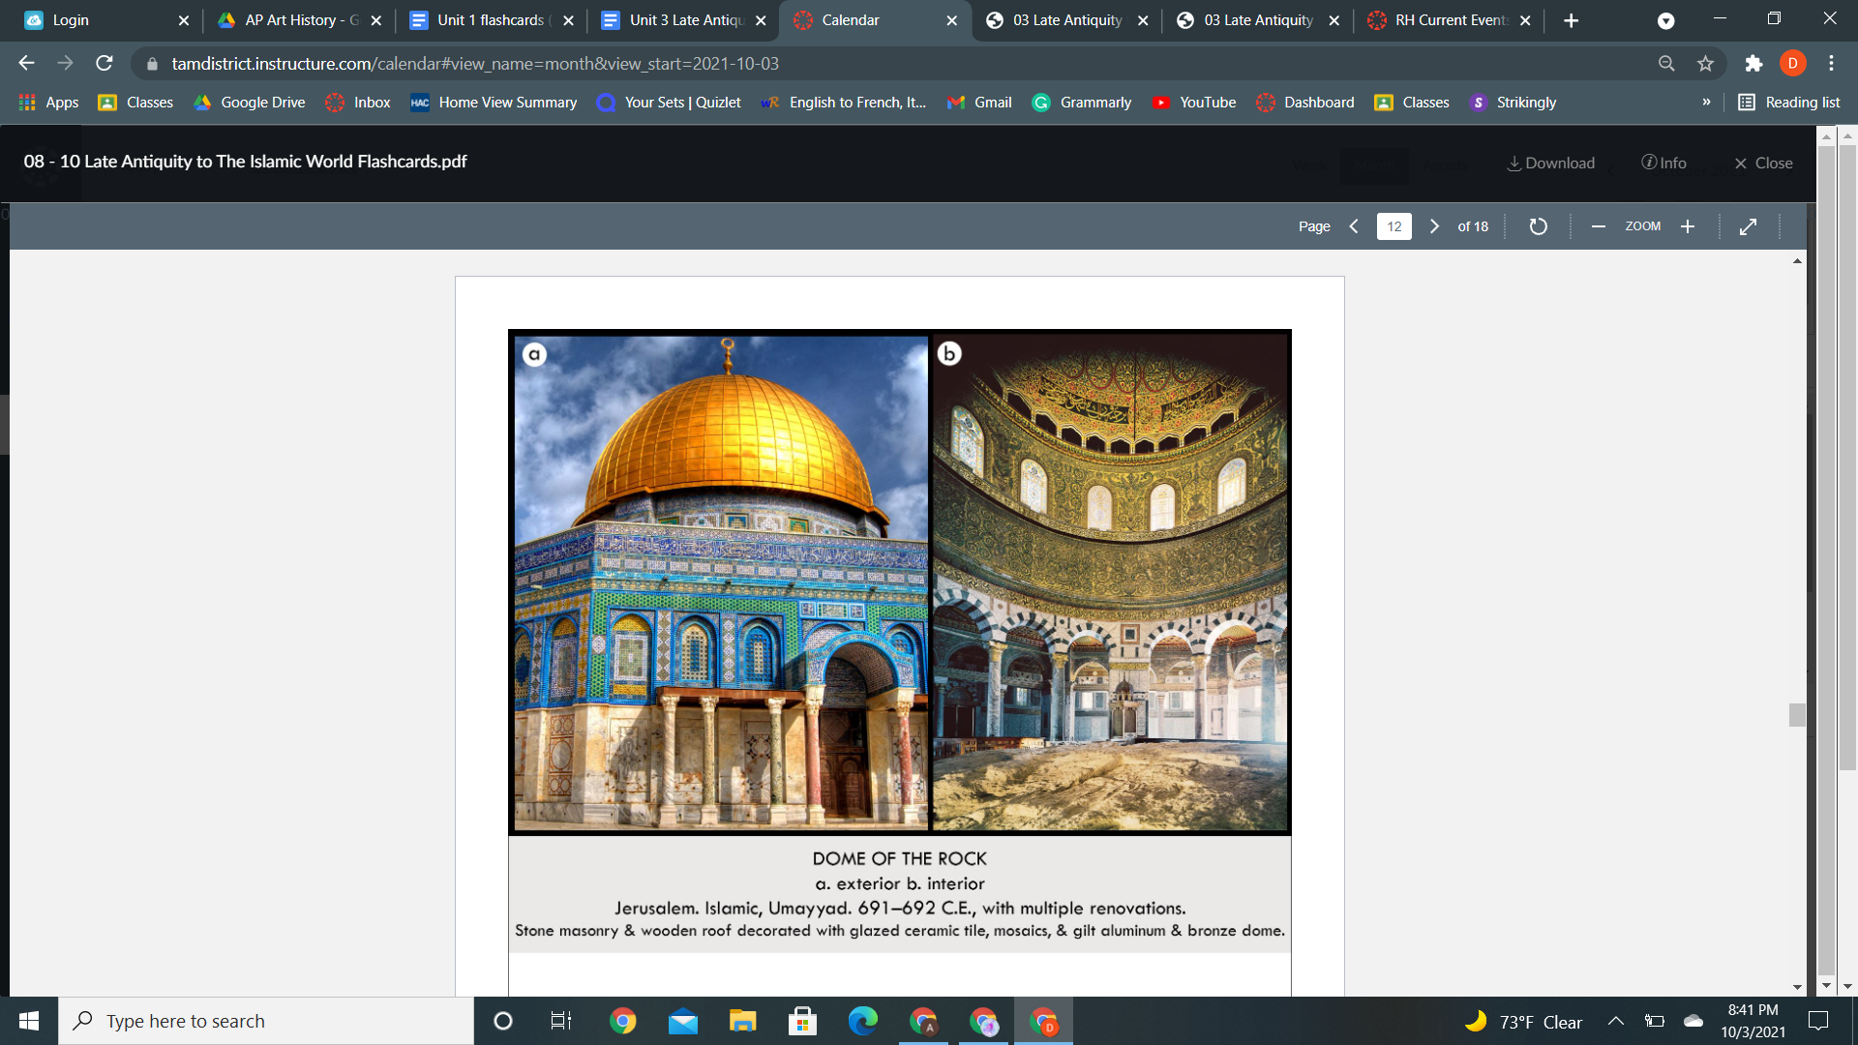

| **Form:**  Wooden dome covered in gold, a dome on an octagon, covered in tile work, circle and square = heaven and earth. Gold leaves covered with a wooden dome . The mosaics are decorating the shrine with Arabic script and vegetal patterns  **Function:**  Made as a tribute to the triumph pf islam. parallel to the form of the Early Christian and Byzantine martyrium.  **Content:**  Built by Abd-al-Mail, Caliph of the Umayyad Dynasty. Centrally planned building, symmetrical in every direction,  **Context:**  16th-century work, first Quran verses in architecture. Sacred location, the site of the Hebrews temple of Soloman, Built by the Nmmayyads. significance across all three religions( The Talmud (Believed that God created the world out of this rock, It was the site of 2 Jewish temples and very important to the Jewish religion.) The bible (It is the location where Abraham prepared to sacrifice his son Isaac to God) The Quaran (This is the place where Muhammad ascended to God on his night journey)  **Compare:**  Pantheon, Higia Sophia, ( any strong religious site)  **185**  West & Central Asia |
| --- |

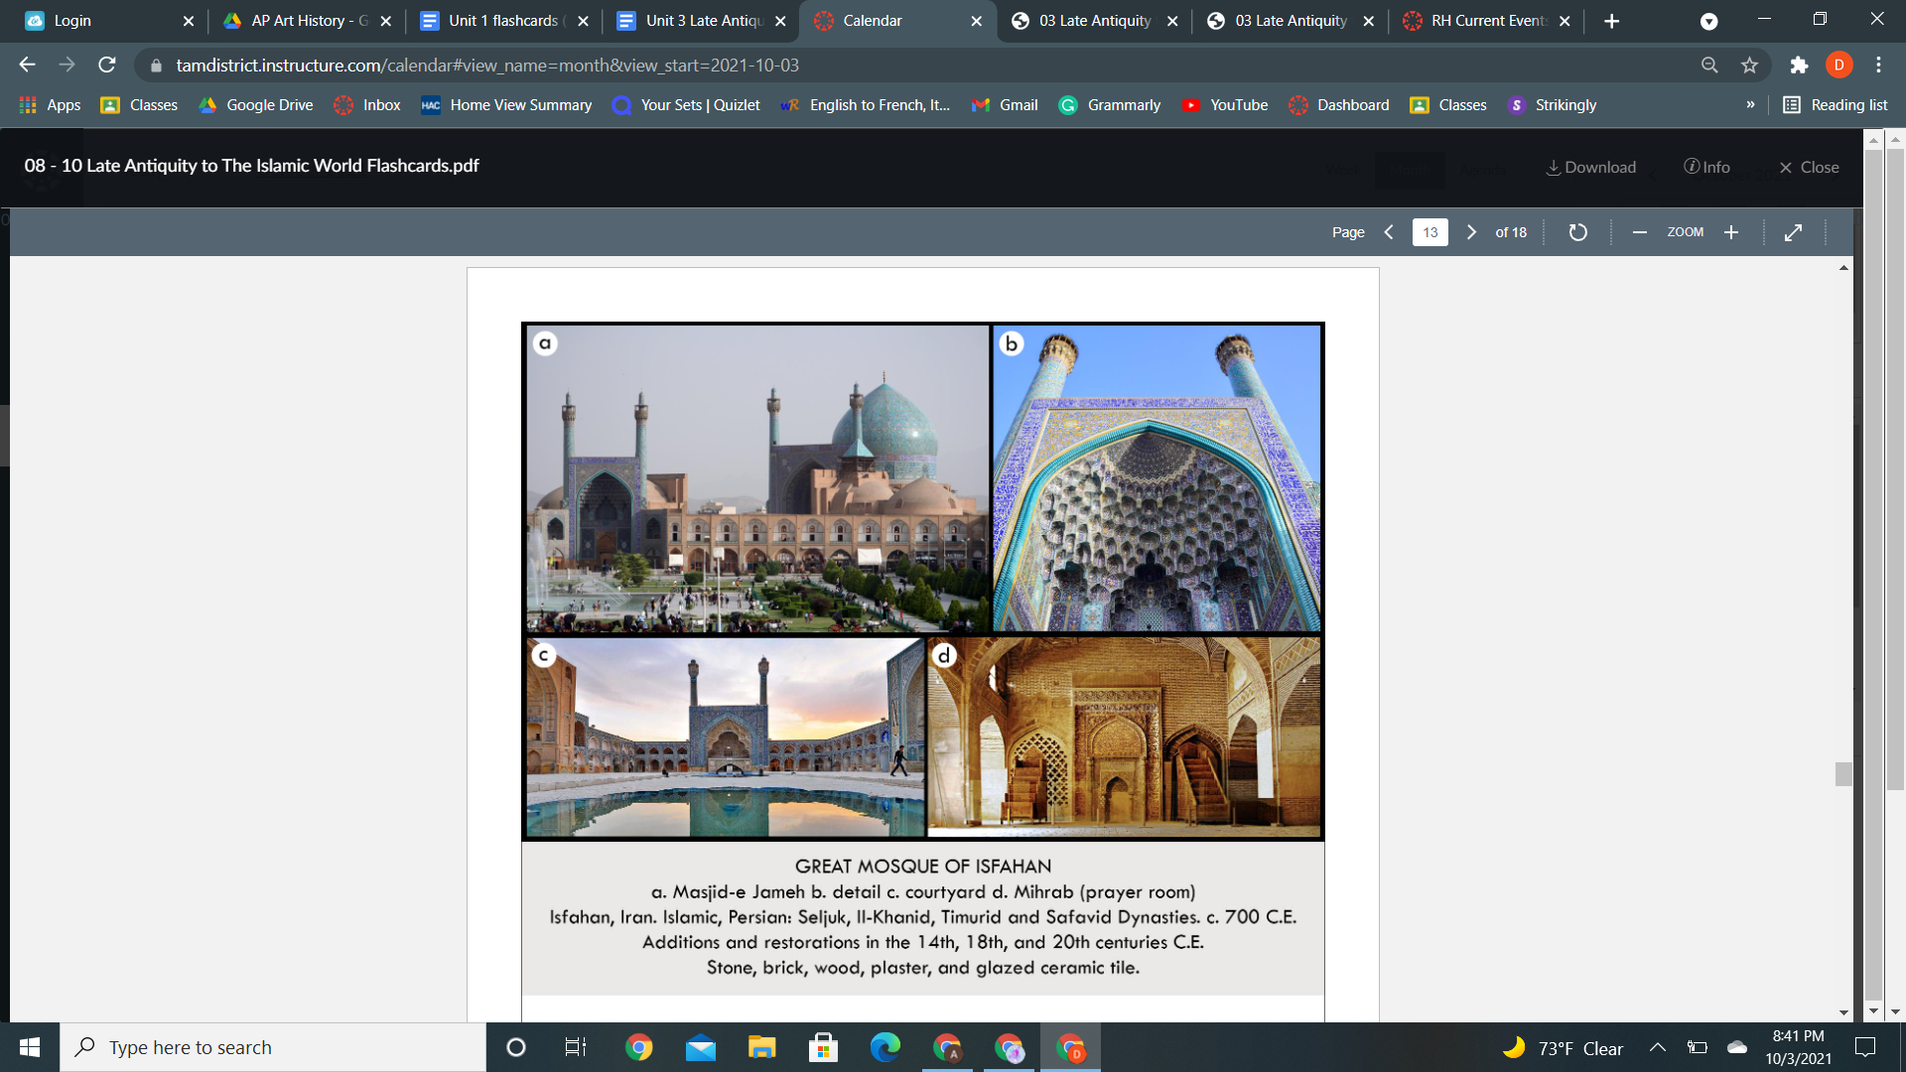

| **Form:**  Bricks and stucco motifs and tilework adorn the space in addition to calligraphy. and modifications that span over 1000 years. Made up of a large central courtyard surrounded by a two-story arcade, Brick piers, and columns that support the roof system. a four iwan design (vaulted, or open space on three sides, last one open) -One is primarily used as a private space used by the sultan and adorned with tiles -4 of them open up to the courtyard, Inscriptions on walls, Centrally planned, use of gold and blue. Marble used  **Function:**  Royal mosque, To bring people to prayer away from busy streets. Unite the community (umma), The mosque's location in the heart of the city makes it a center for gathering and transportation, Commercial activity  **Content:**  Calligraphy covers the arches and walls representing intellectual beauty. Has towering minarets for the call to prayer.  Interior- hypostyle hall, Vaults bring in light and ventilation, The dome undersides (soffits) are carved with intricate geometric designs and have an oculus--muqarnas- traditional Islamic cusped niches, Isfahan's covered bazaar connects to the mosque, turned towards Mecca, No closed areas  **Context:**  Built Between 1612 and 1637. Country was Persia at the time now Iran, ruling groups of Isfahan include Il-Khanid, Timurid, Safavid, and Qajar, the mosque visually embodies the visual tastes and political dynasties of the Persian empire, Original plan comes from the 11th century when the Seljuk Turks established Isfahan as their capital. Nizam al-Mulk (commissioned the dome in 1086)  **Compare**  **186**  West & Central Asia |
| --- |

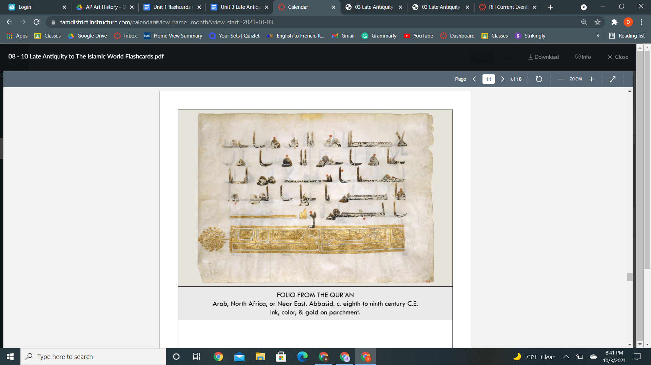

| **Form:**  Folio page from the koran- codex, ink, and gold- applied to the page on animal skin( parchment ) Two page spread Qur’an manusare,silverareIranianript, Kufic, read from left to right, The text of the sura is divided into verses by triangles made up of 5 gold circles which is located at the end of each verse  **Function:**  Holy book  **Content:**  No written down entirely until much later, Kufic writing  **Context:**  Arabic script is read from right to left. Small dots vowels, very legible text from a distance. The oldest full text of the Koran is from the 9th century. No pictures  **Compare:**  **187**  Early Europe & Colonial America |
| --- |

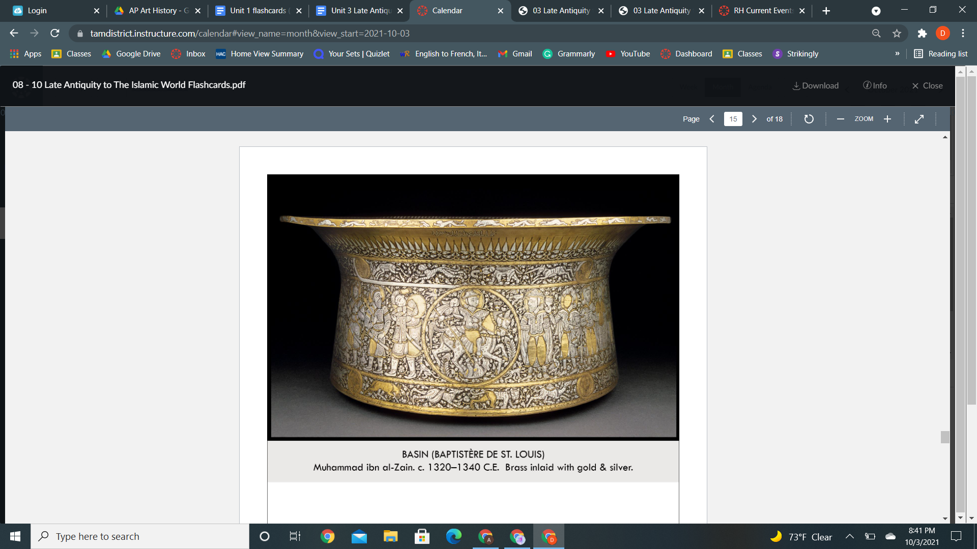

| **Form:**  Basin, made of brass, areas of silver and gold, a frieze of men on horseback.  **Function:**  Washing hands at the official ceremony- becomes the basin for the french royal family- for baptism (children of the royal family)  **Content:**  Made by Muhammad. The hunting scene shows imagery in an Islamic context. Signed 6 times by artists. Bottom with eels, fish, crocodiles. Scenes of battle, violence, very dense figures. Covered in images everywhere except the inner sides. Movement and energy in forms and figures.  **Context:**  Comes from the area of Egypt and Syria. Known as an extraordinary craftsman, no Islamic inscriptions which are uncommon  **Compare:**  **188**  Early Europe & Colonial America |
| --- |

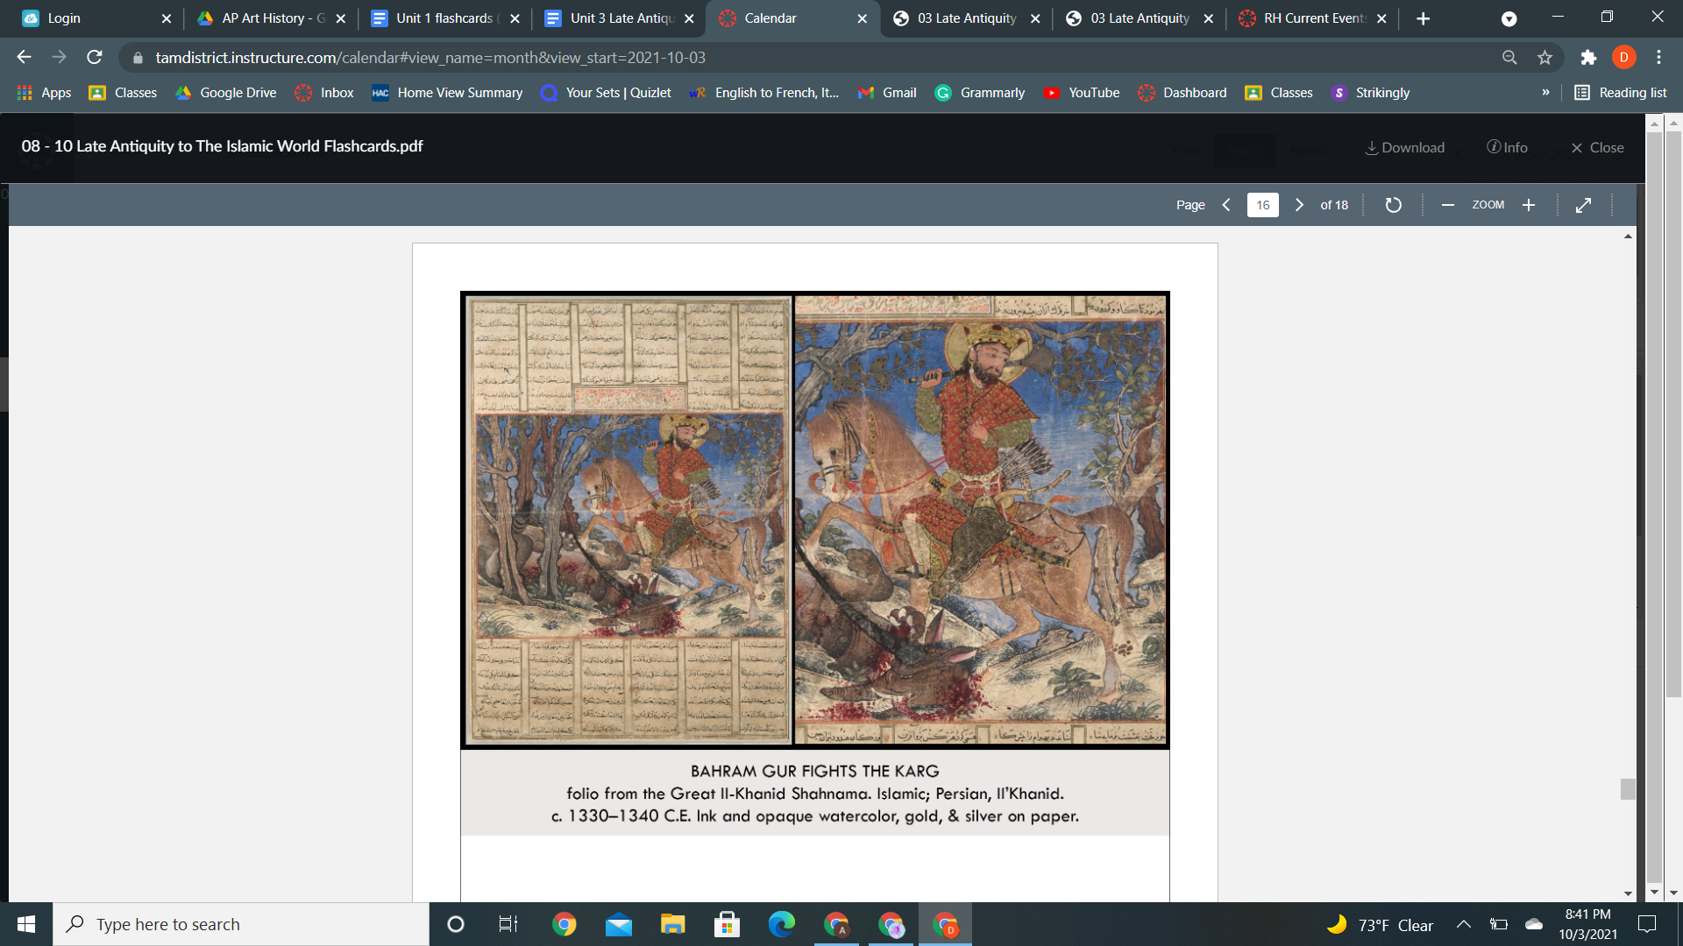

| **Form:**  Ink watercolor, gold and sliver on paper.  **Function:**  Books is called Illustration of the iranian book of kings, the shahnama= stories of every king of Persia of all time. ( ruler from sectarian Persia dynasty)- record of all kings- history book  **Content:**  Show story of rules defeating the carb- mythic creature( king=Bahr am gur wolf). Artest looking at Chinese landscape scrolls - trees drawn is heavy dark lines, European influence of the way he’s riding the horse and his body.  **Context:**  timurid= became briliang mintaturists and. One of the first papers in the west. Artist uses multi-cultural art and references. Miniaturists became very famous and popular  **Compare:** Fan Quan travels amongst rivers and streams in the mountains - landscape  **189**  West &Centrall Asia |
| --- |

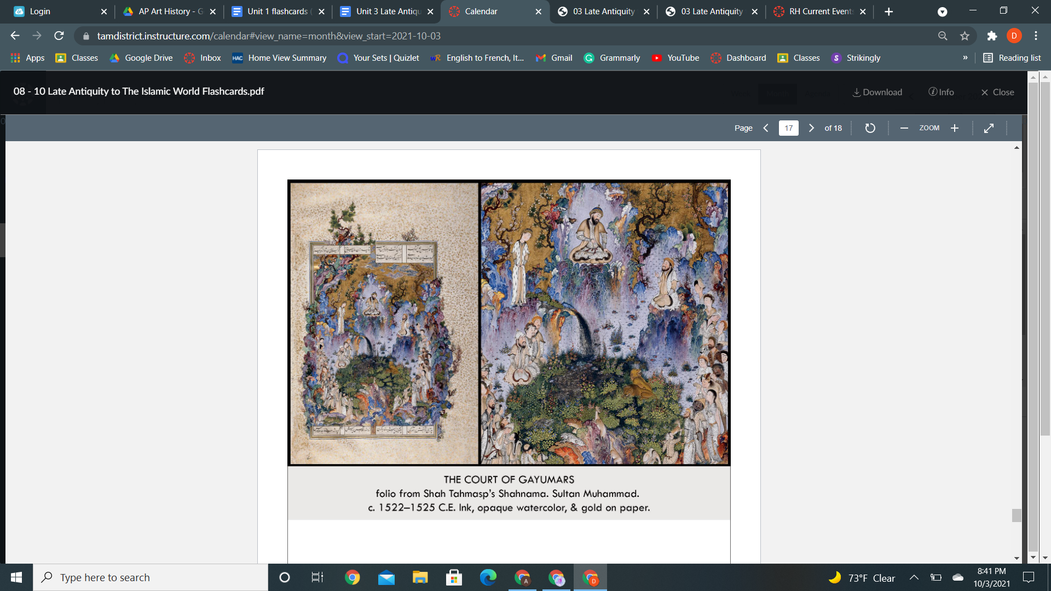

| **Form:**  lapis , malachite, gold, silver, on paper  **Function:**  Shahnameh( 60000 poems, history of kings) =Page from the book of kings  **Content:**  Light and feathery illustration, very stylized and complex, embedded figures, people, animals. Principle figure bringing civilization to the world demonstrates harmony. Filled with vegetation, a paradise. Pointing to his son. Landscape spills onto the page. Sense of depth. Chinese painting aspects. Includes calligraphy= about the history of Persia. Painting about Gayumars who is the first king of persia= mythic. IdyllicCentral image made by saltin mahamen talked about. Upturned landscape from far away.  **Context:**  Most famous Persian miniature, 3 sections of the. Artists took some technics from other places and china. At the time of creation of the Iranian revival. Written about and recorded about. Persia sat at the western end of slik world, great chinese influence.  **Compare:** chinese landscape art  **190**  West & central Asia |
| --- |

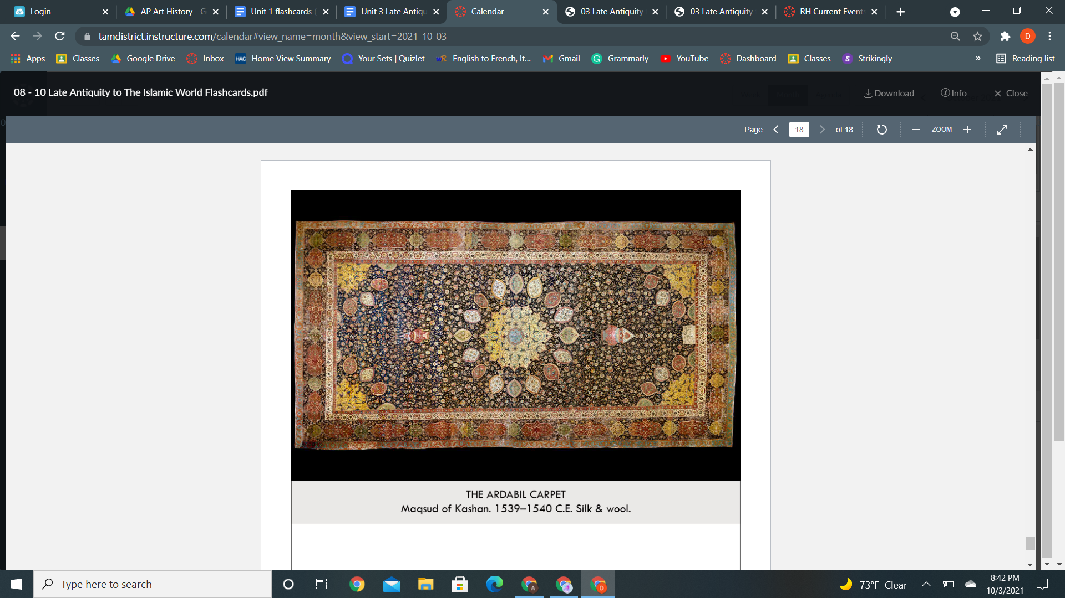

| **Form:**  34 ft by 17 ft made of silk and wool from sheep/caterpillars, spun and woven into the carpet - technique. Fibers are dyed colors before placed, arrayCentralChineseinfluenceChineseThe s, made with natural dyes- reacts to light. 25 million knots 340 from a square inch  **Function:**  Prayer carpet ( Muslim) one of a matching pair from a funerary mosque from shaykh Safi al-Din( place to bury the dead and pray) - rug for a funerary mosque  **Content:**  Pattern of horror vacui design( no empty space), has an interior motif in the middle, radial symmetrical mostly, vegetal motifs and patterns along the sides. Has images hanging on the left and right. Middle area called the medallion, intended to be standing over the surface of a lake is reflecting the architecture of the mosaic above you. middle= dome and around the dome = lamps hanging around it. ( looking across the surface of the water ) illusionistic motif. Squintage in the corner. No human or animal figures.  **Context:**  World's oldest dated carpet- luxury arts often not signed, woven by 10 different people. Represents a lake/ looking at a reflection on a plate. Commissioned in the 16th century. Statement of the dynasty to rule and recognize kingship.  **Compare:**  **191**  West & central Asia |
| --- |